ZERO DISCRIMINATION DAY :- HUMAN RIGHTS CAREER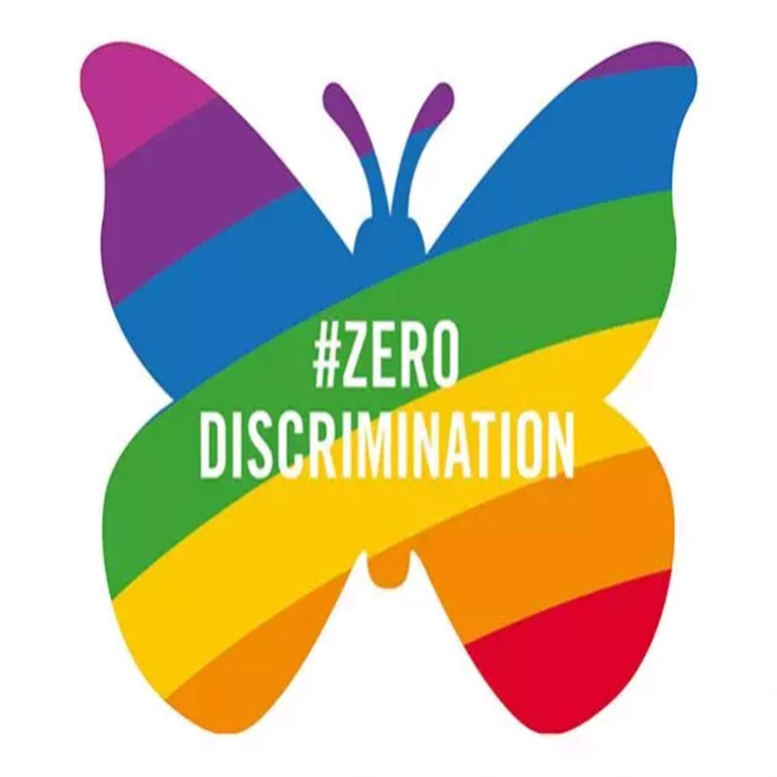

The International Day of Zero Discrimination is an officially recognised day that the [United Nations](https://byjus.com/free-ias-prep/united-nations-organization/) celebrates with other international organisations. Zero Discrimination Day is celebrated on 1st March every year. It was first celebrated on 1st March 2014, and introduced by Michel Sidibe, UNAIDS Executive Director, thanks to a significant event in Beijing on 27th February 2016.

**Zero Discrimination Day: Why is it Important?**

* Zero Discrimination Day 2022 aims to stress the immediate requirement for addressing global inequities based on wealth, gender, age, health condition, employment, disabilities, sexual orientation, substance addiction, gender identification, ethnic background, religion, and faith.
* Zero Discrimination Day demonstrates how individuals may learn about and encourage inclusiveness, empathy, tolerance, and, most importantly, a cause for change.
* The day seeks to promote equality before the law and in practice in almost all UN member countries.

**How is Zero Discrimination Day Recognised?**

* On Zero Discrimination Day, 1st March, we recognise everybody’s right to a complete and fulfilling life to lead it with respect.
* Zero Discrimination Day contributes to creating a worldwide solidarity campaign to abolish all forms of discrimination.
* Organisations like UNAIDS, which fight intolerance against persons living with [HIV](https://byjus.com/free-ias-prep/hiv/)/AIDS, take special note of the day.
* In 2017, the UN Development Programme paid homage to LGBTI persons living with HIV/AIDS who encounter harassment.
* **The symbol for Zero Discrimination Day is a butterfly.**
* Individuals frequently utilise a butterfly symbol to communicate their experiences and images to eradicate discrimination and strive toward positive development.
* Zero Discrimination Day was established on 1st March 2014, by [UNAIDS](https://byjus.com/free-ias-prep/unaids/) Executive Director in Beijing, following the launch of UNAIDS’ Zero Discrimination Campaign on 1st December 2013, i.e., World AIDS Day.

**Zero Discrimination Day: History**

* [UNODC](https://byjus.com/free-ias-prep/united-nations-office-on-drugs-and-crime-unodc/) has long advocated for increased attention to the HIV suffering of critical communities.
* Specifically, the shame and injustice they encounter daily.
* Drug users and inmates experience stigma and prejudice in various ways, ranging from purposeful denial of rights to essential health care to physical and emotional violence.
* The stigma and injustice they endure typically reflect how the wider community regards and treats them.
* It arises from their classmates, relatives, neighbours, and health care professionals.
* Discrimination is frequently detrimental to the level that significant gaps in availability to evidence-based HIV protection, medication, therapy, and assistance exist between vulnerable populations and the majority of a community.
* It also influences how resources are allocated to HIV preventive and medication initiatives, how plans and regulations are designed, and the general health outcomes of drug users and persons in jails.
* Responding to HIV by adopting evidence-based treatments for drug users and individuals in jails necessitates confronting prejudice straight on.
* Discrimination violates human rights. It’s against the law, immoral, and degrading.
* To eradicate discrimination and its consequences, we require commitment at the individual, social, and governmental levels.

**World Overview: Zero Discrimination Day**

* The world can indeed defeat AIDS, but only if we confront the socioeconomic inequities that promote it and encourage further scientific advances to tackle the genuine requirements of women and girls, as well as those living with and at risk of HIV.
* AIDS is still the leading cause of death among women aged 15 to 49 globally.
* To eradicate AIDS by 2030, we must eliminate gender-based abuse, discrimination, and vulnerability and provide equal access to school, healthcare, and work for women and girls.

### Conclusion

The Zero Discrimination Day is an opportunity to bring attention to the disparities that restrict individuals from leading full and productive lives and call on governments to fulfil their pledges and duties to eradicate all kinds of discrimination.



